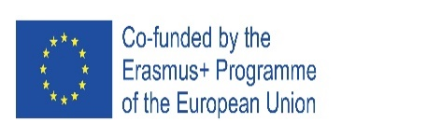
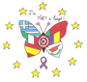
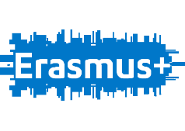

Cyprus Mobility Feedback Report

Erasmus+ Project, Strategic Partnership for School Education, Cooperation for Innovation and the Exchange of Good Practice

Project title: “I AM NOT A TARGET!” Number: -2018-1-RO01-KA229-049059

Event: Short-term joint staff training Host organization: Gymnasio Agias Paraskevis Geroskipou

Place: Pafos, Cyprus Date: 26TH -30TH NOVEMBER 2018

Introduction

The Cyprus Mobility have been completed successfully. The objectives of Cyprus mobility was to:
- introduce the members of the Erasmus team with each other;
- share good practices from school (i.e the socio-ecological anti-bullying program “ViSC-Together Against Violence”);
- participate in workshops and seminars on bullying with national experts;
- understand the multi-cultural context of Cyprus with visits in historical places.

Summary of Feedback
The Mobility in Cyprus was between 26th - 30th of November with 14 participants. 13 participants participated in the feedback questioner. 15.4 % of the participants were between 31-40 years old, 46.2% were 41-50 and the rest was between 51-60 years old. In the question “Which is your motivation for this short training session with Erasmus+ project?” more of the 50% of the participants replied to learn by other cultural and practices, to learn about bullying, to learn in an intercultural environment and because they think the topic is of high importance. The least favor motivations were to have training session in English and personal development.
Regarding the practical arrangements made by the host school, from the scale 1-5 meaning bad-great, 9 participants replied that it was Great and Very good, while 1 replied Bad (1), 1 chose average (2) and 2 chose Good (3). In the question regarding the organization of activities in and out of school, the majority replied that it was Good, Very Good and Great. One participant replied it was Bad while another one replied aAerage. The time management of the activities was considered very good in general with 7 replied Good, 2 Very Good and 5 Great. The safety and risk measures was again considered very good with 5 replied Good, 1 Very Good and 6 Great. The communication with partners was very good with most replied that it was Very Good, 4 replied Good and the rest Great. The participants have also shown to believe that the safety and risk measures were very good in general.
The participants have been asked to what extent the activities during the visit in Cyprus have developed their capacities and aptitudes to: (a) identify bullying in school, (b) value emotional intelligence and socio-emotional learning in teaching, (c) use modern digital tools and e-lessons, (d) create/develop of modern and digital tools and e-lessons, (e) transfer in their practice the experience, expertise, results and policies of their host school, (f) create an early intervention plan, (g) change the teaching style in sens of more flexibility and empathy with emotional feelings of students and finally (h) transform learning environment in their class and school in sense of imperfect pace in diversity. Most participants replied from Average to Great Extent.
Regarding the competences the participants improved after their visit to the host country, 69% shown to improve their teaching/planning with focus on socio-emotional learning while the rest they were not sure. 77% have shown to improve their managing skills on bullying situations in schools while the rest replied that they were not sure if they have improved that. 46% of the participants have shown to not learn any new processes in teaching using digital tools while the rest replied maybe. 77% of the participants replied that they have improved their teaching process in making the lessons more attractive while the 23% replied maybe. 85% of the participants have shown to improve their communication in English while the rest said no and maybe. 92% have improved their interpersonal communication. Regarding the intercultural communication 100% of the participants was positive.
69% of the participants have shown to learn new educational methods and strategies which can be used for bullying preventing and early-intervention. The rest weren’t sure if the have learn that.
The participants found in general very and great useful their work in intercultural teams. Also they found the emotional learning very important for improving the relationship between teacher and students and to create a safe and confident learning environment in classroom and school.
The interactive creative workshop on bullying and the seminar by the lecturer were identified by the participants as the most useful activities during their visit in the host country.

Conclusions

The conclusions drawn from this report are the following:
- Most of the participants apart from 1 were positive in terms of competences and capacities they have improved. The practical arrangement was considered very good from most of the participants except from 1-2.
- Improvement should be done by the host country to use more digital tools for the interaction with the participants so that they would learn using digital tools in their teaching process.
- The host country should have added more seminars/workshops on bullying by experts.

